OFDM Profile Analysis – Not showing locked

Example: Profile C Not showing locked

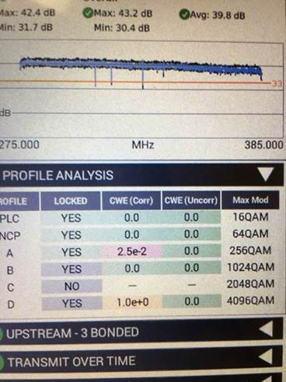

As for the Profiles not showing locked, looking at the photo sent we can see there are 4 total profiles being advertised by the CMTS (A, B, C, & D). The ONX uses the PLC data to determine how many Profiles are expected to be present. The ONX looks to determine if it can then demodulate traffic on those profiles. If the ONX is capable of demodulating the traffic on a specific profile it will show that profile as a “Locked” profile.

In the ChannelCheck mode the ONX is sniffing the data on all the profiles in an attempt to determine if it can lock onto those profiles. Typically, we see the profiles as being “Unlocked” because of either of two situations. Either the profile is too degraded to be locked onto, meaning the modulation may be too high for the current location’s signal quality conditions, usually low MER. Or as is more common in testing scenarios, there isn’t enough data being transmitted on the profiles shown as “Unlocked”. Usually this is due to little traffic by only a few modems which are not very active at the time. If there isn’t enough data on those profiles the ONX can’t determine that the data is good or bad since there just isn’t enough of it.

In the DOCSIS modes the ONX is able to determine which Profile it can communicate with as well as monitor the other profiles. So, in a live two-way communication the ONX may show “Locked” on more profiles since it is actively contributing to the flow of data traffic on those profiles. Sometimes we see Profile A and other higher Profiles locked but intermediate profiles not locked. In the shown example Profile A, B, and D are locked, but C is not. In these cases, the ONX is communicating on the highest Locked profile (D) but not the other Profiles B or C. Every modem periodically talks on Profile A for keep-alive communications, so profile A is always locked. Because modems and the ONX will always try and utilize the highest bandwidth profiles they can Profile D is locked as the ONX communicates using that Profile. The other profiles may still show not Locked if other modems using the other Profiles are not very active. Again, when there isn’t enough data on those Profiles to make a determination of a Lock the ONX can’t determine the quality of the other profiles, so they are shown as “Unlocked”.

In this Example, we suspect that low traffic is the reason for not showing a Lock on Profile C for the situation as it has been presented.