Fault Management

OverView :

Skylo’s Fault Management is a Crucial and most important module in Skylo Environment. This module is a Replication of Apache Kafka which is deployed as Google Pub/Sub in GCP .   
  
  
Here we Receive data from the Pub/Sub Topics and Consume the data from Topics and Publish it into the UI .

UI :

Alarms Will be categorised based on the priority like critical , major and minor ,   
  
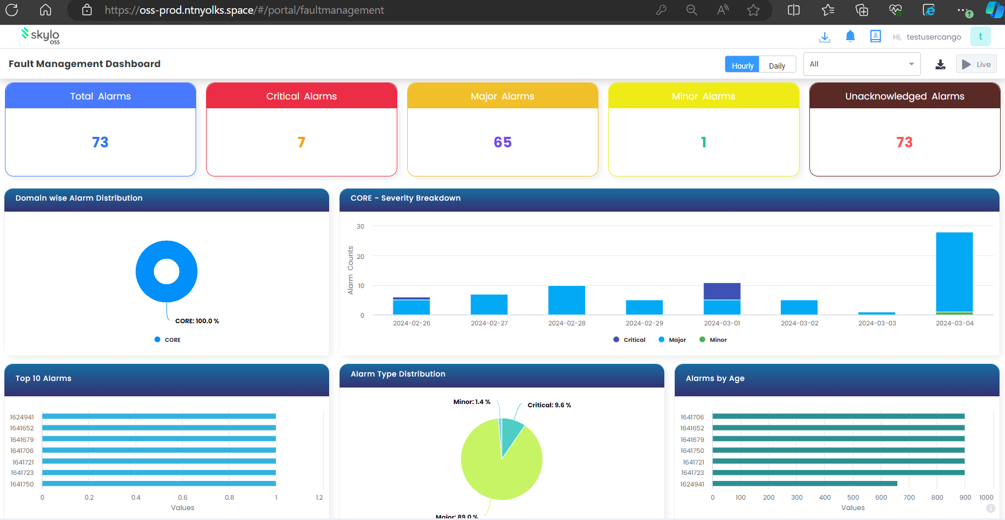  
  
  
when we click on a tile based on the priority example when we click on critical alarm tile . We can able to see the alarms which is listed as critical  
  
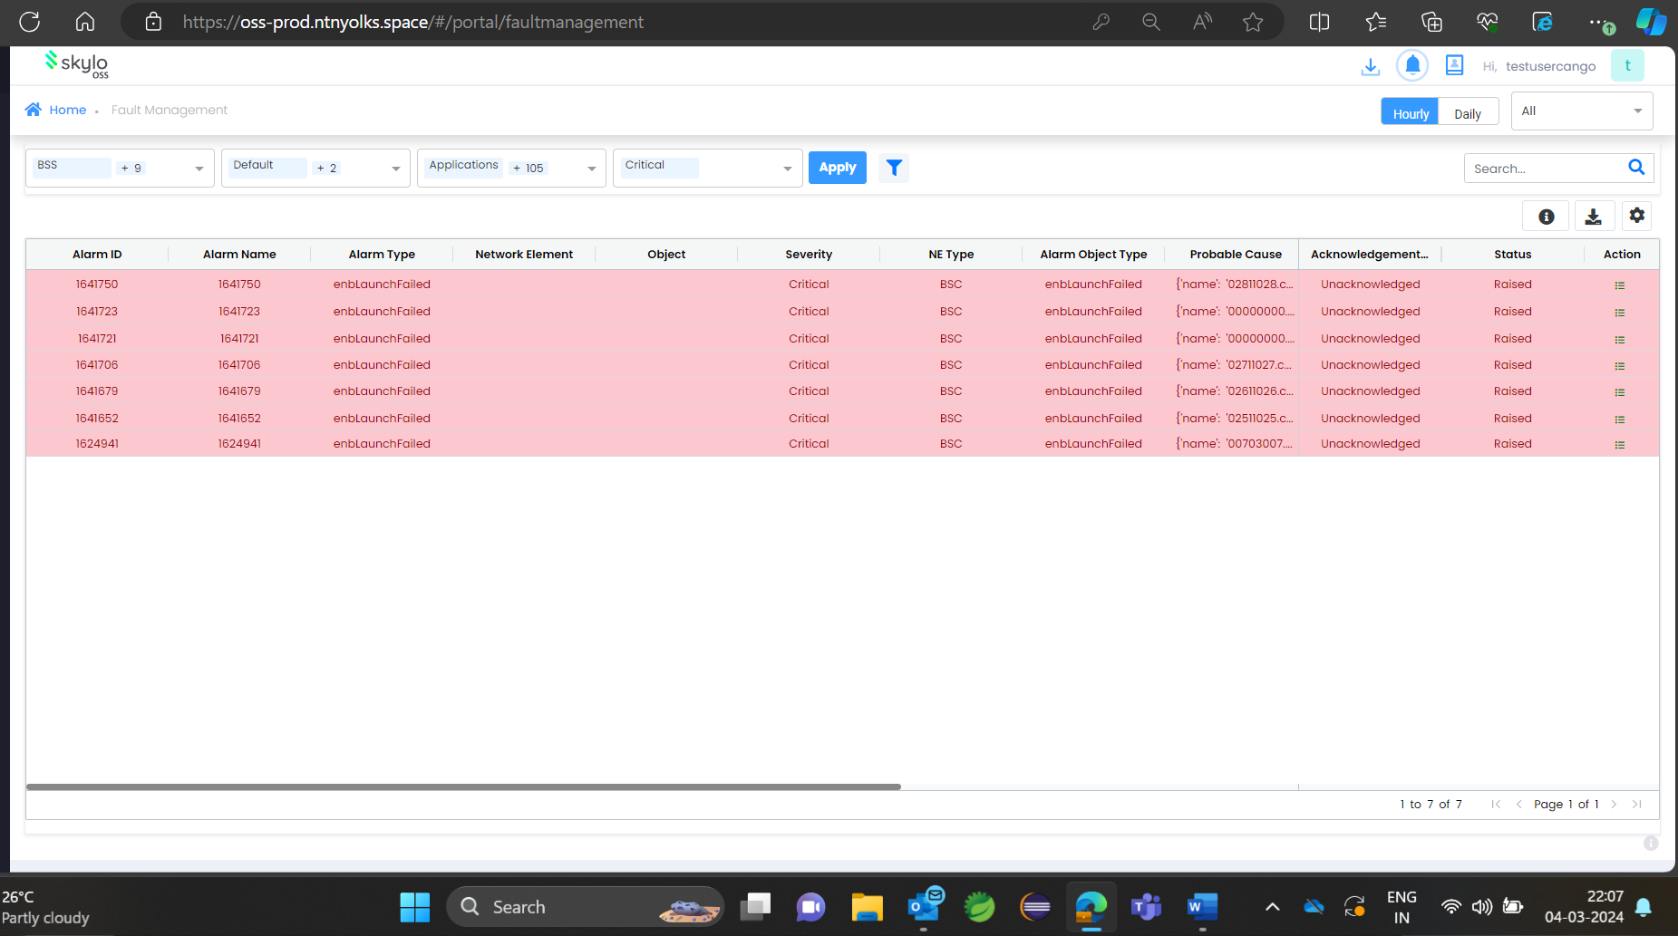

When double clicking on an alarm , we can able to see the characteristics and identification of the alarm such as alarm ID , alarm name ,NE type , created at , occurrence date etcetera

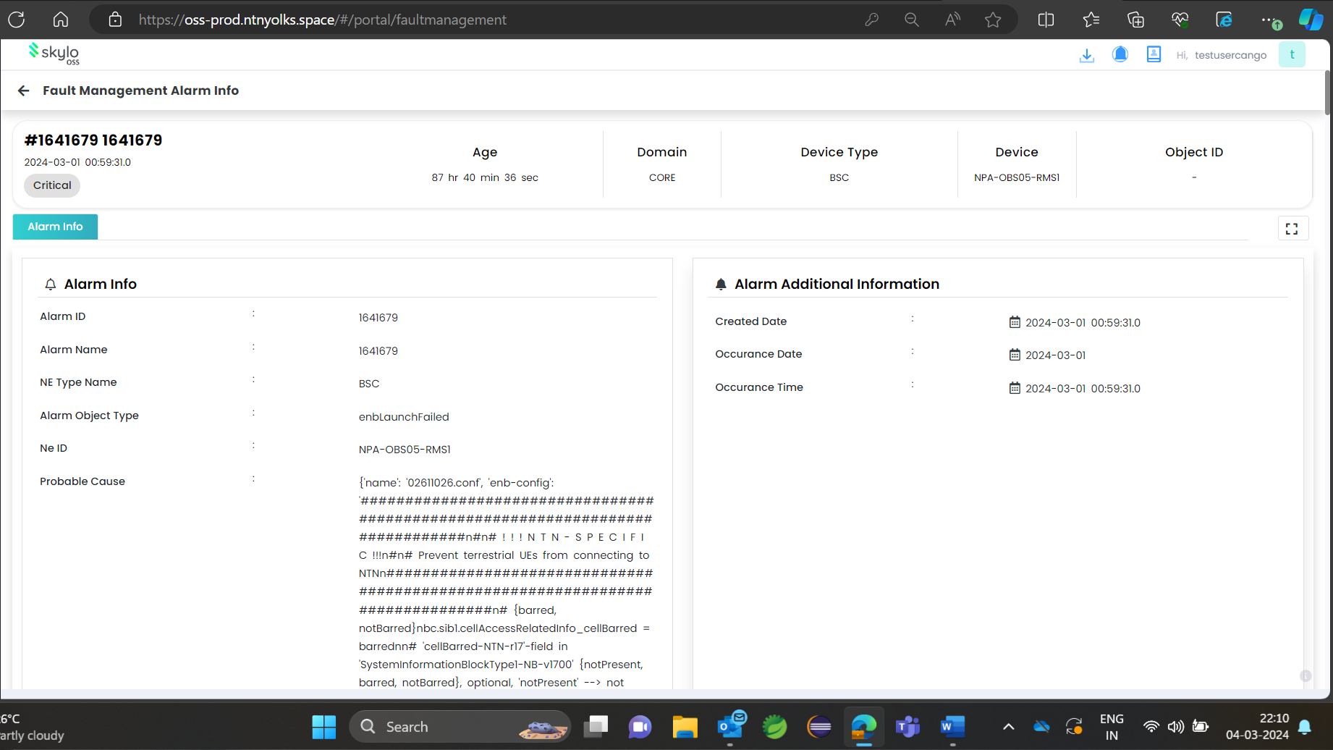

When we hover on the side menu and click on alarm list we can able to see all the alarms regardless its priority . The alarms will be stacked as newest in the beginning and the older messages will be followed consecutively .

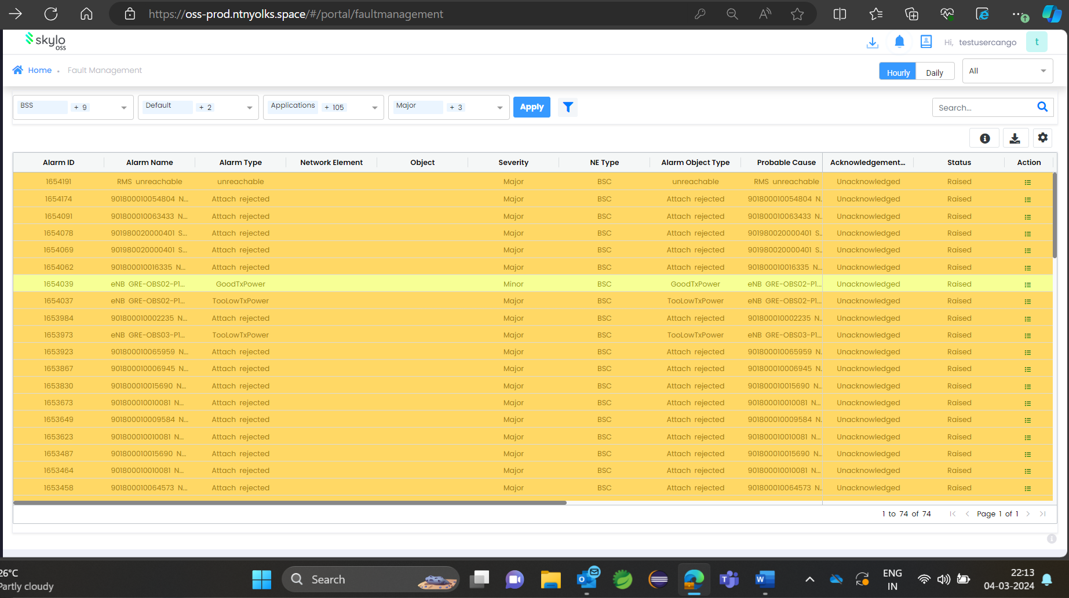

Backend Logic :

Google console Topic Message Logic :

Now we can able to see the topics from where the messages were being consumed from the Pub/Sub . The topics are created by customer and the message is being published will be landing in the topics after that the fault management micro service will consume the messages from the topic and insert into the database and will be shown in the UI

Go to Google console and search for Pub/Sub . the Pub/Sub Will be listed now click on the service .

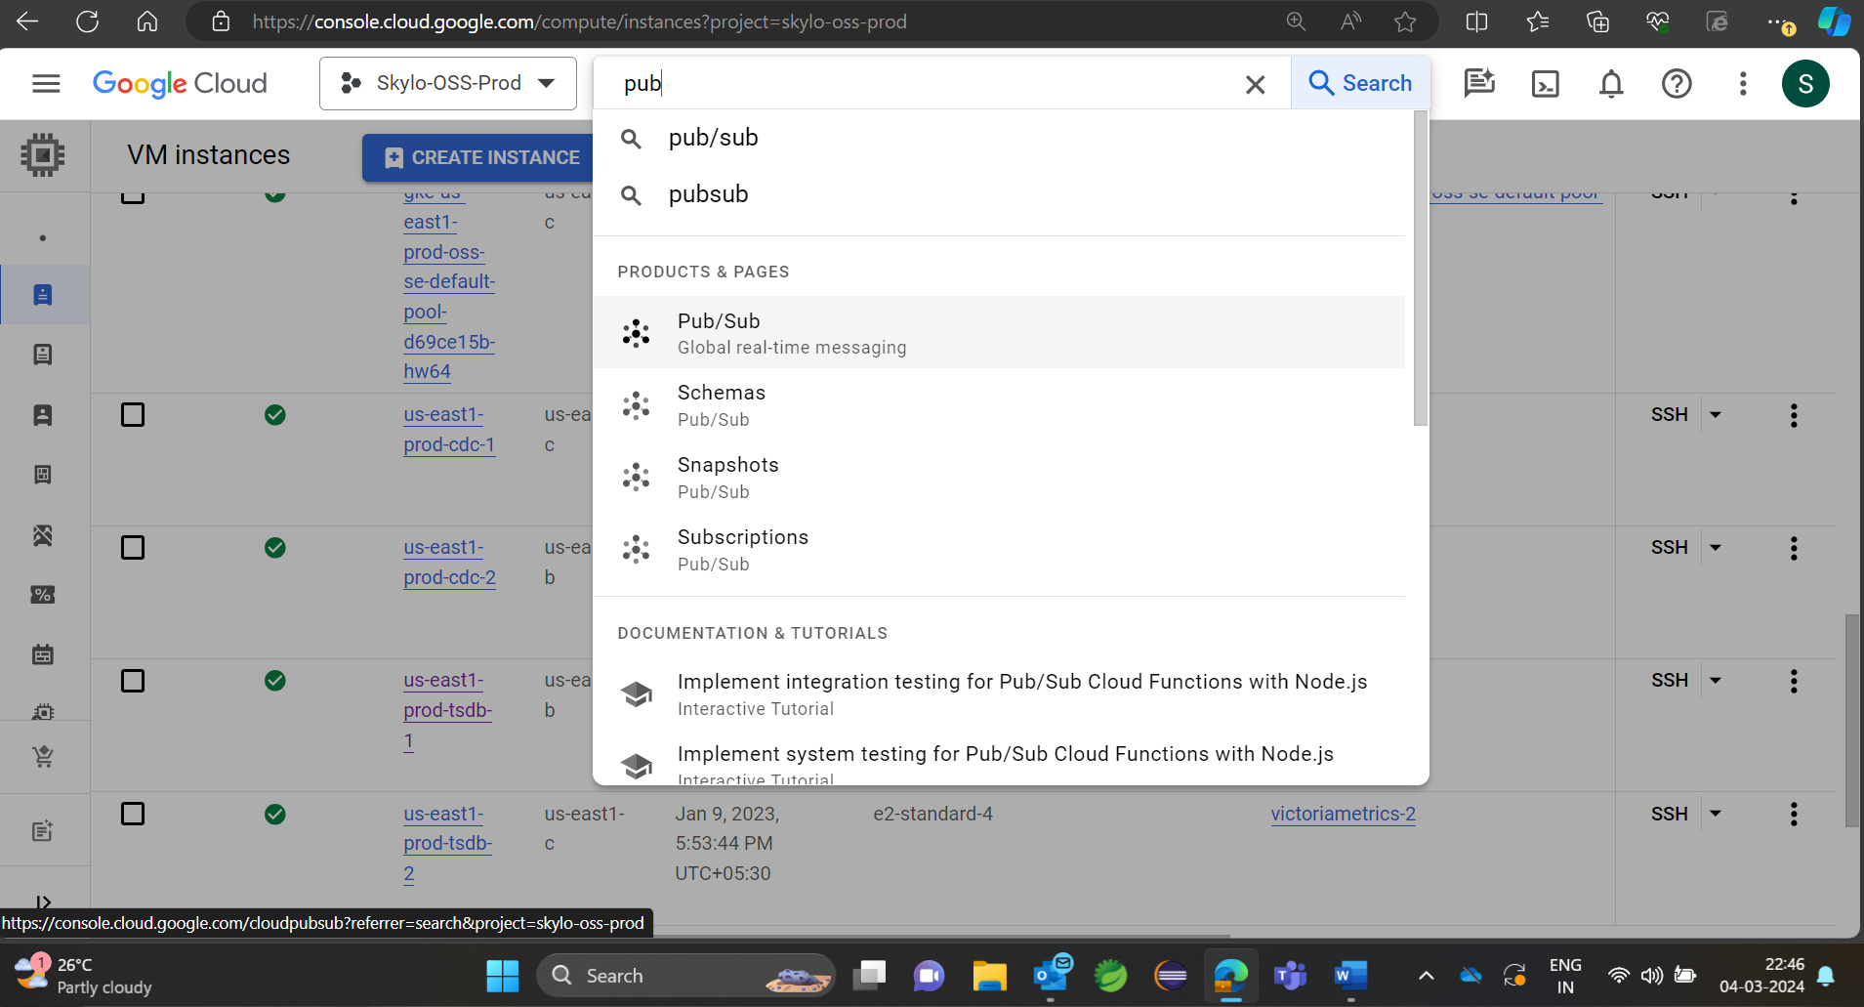

Once the service is clicked . We can able to directly see the topics which are created by the customer since there is no backup created for these topics by the customer we cannot able to see any backup topics for these topics which are alive .

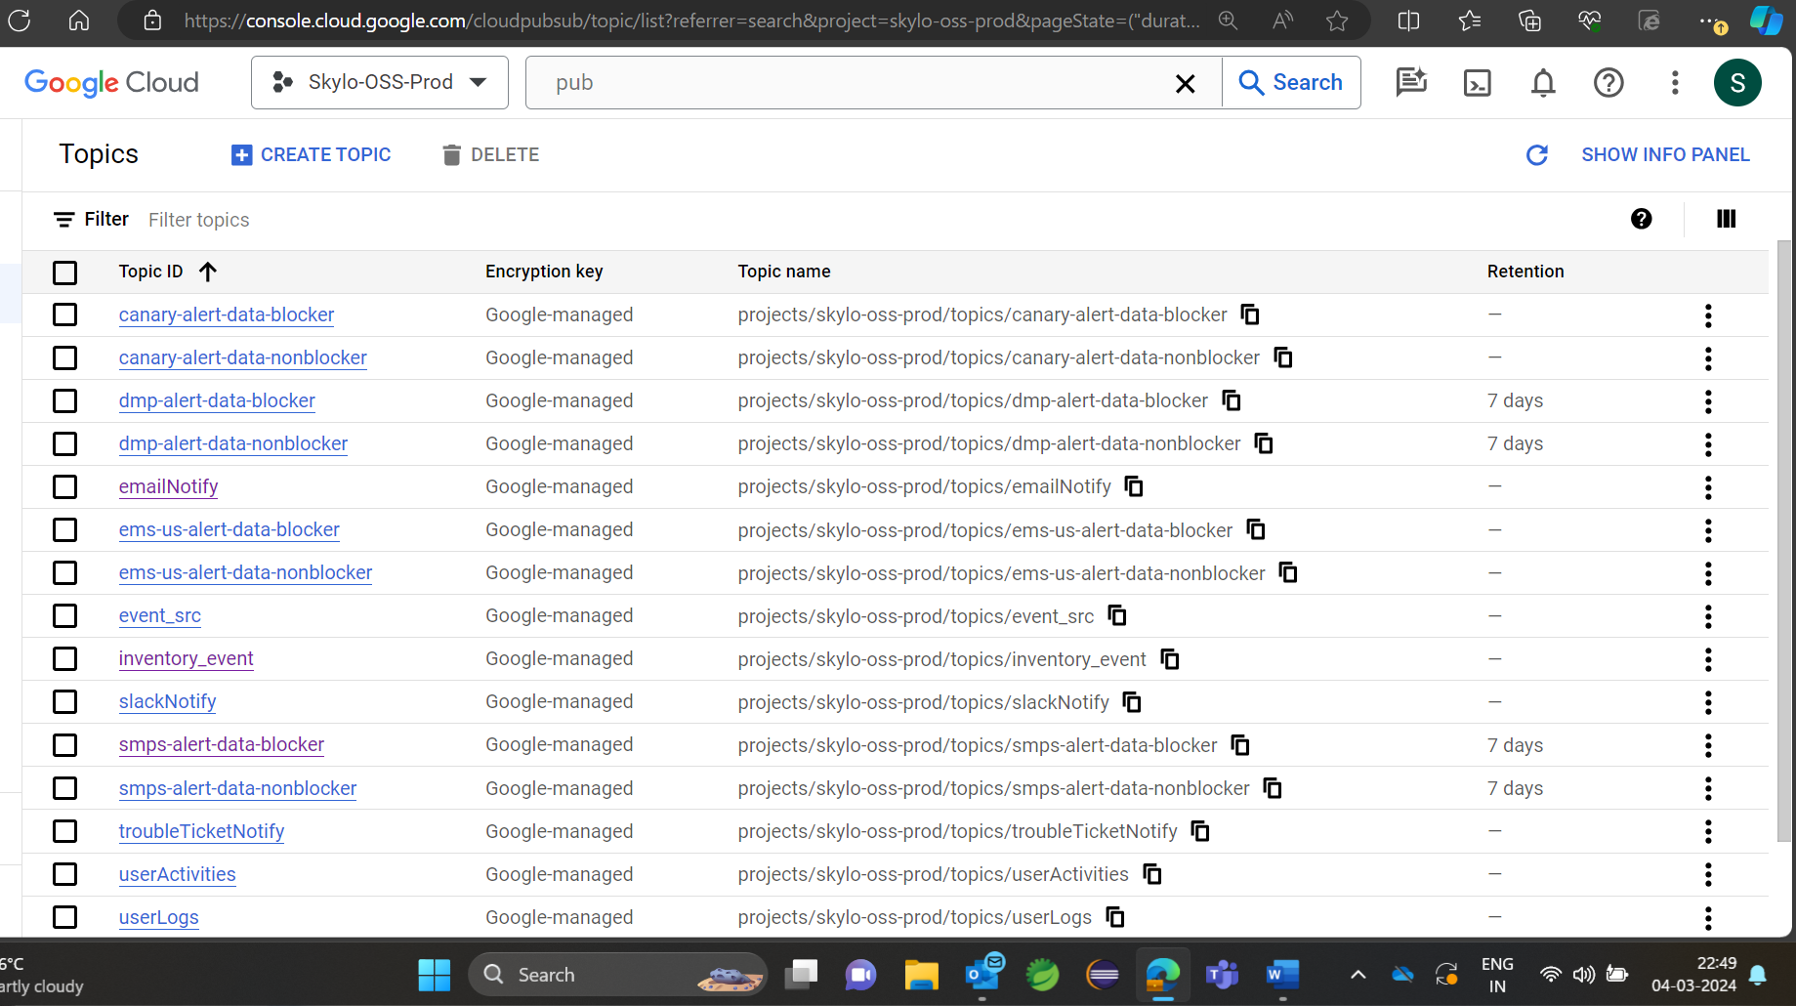

When we click on any of the topic mentioned here we can able to see the subscription for the topic

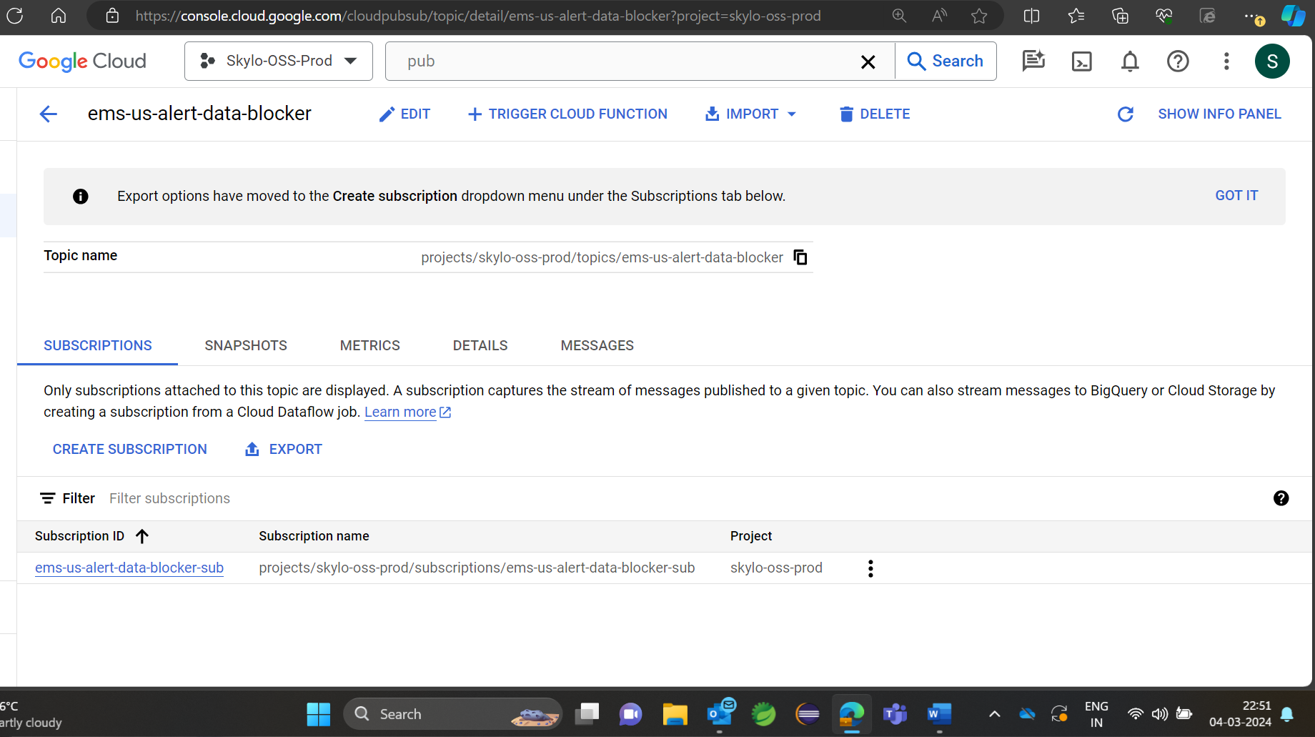

FM POD life and Log Analysis  
  
Fault management is running as micro service in the GCP environment in Kubernetes POD. This kubernetes POD he is collecting data from the assigned topics in Google Pub/Sub .   
For getting into the Kubernetes POD Get into the Google console and click on TSDB1 .  
  
  
And click on “SSH” .

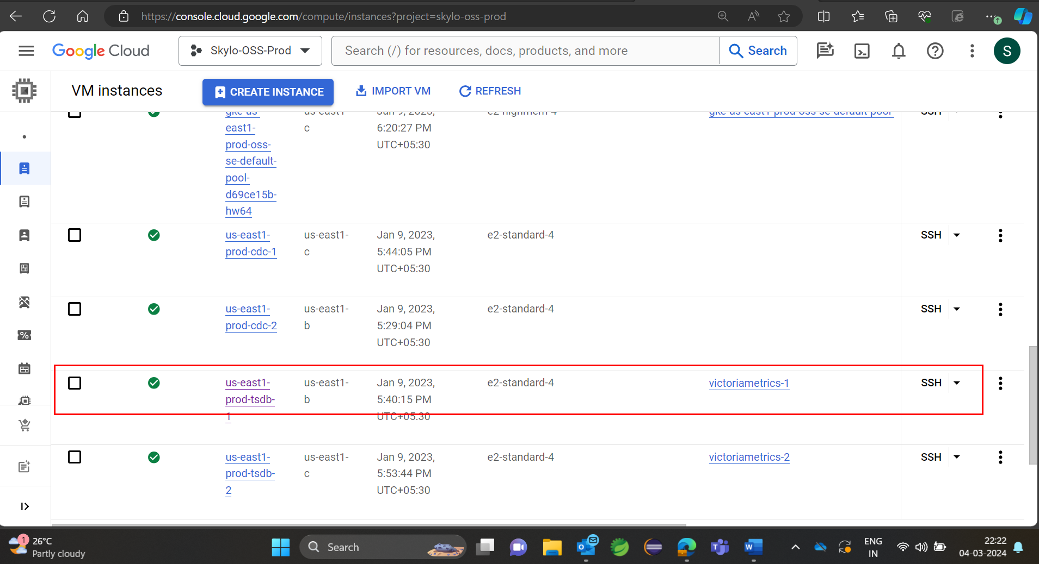

Now Enter “kubectl get pods” , all the pots alive where show me now the fault management pod will be shown in the listed elements . This Pod status and the life of the pod is shown pod age and POD status .

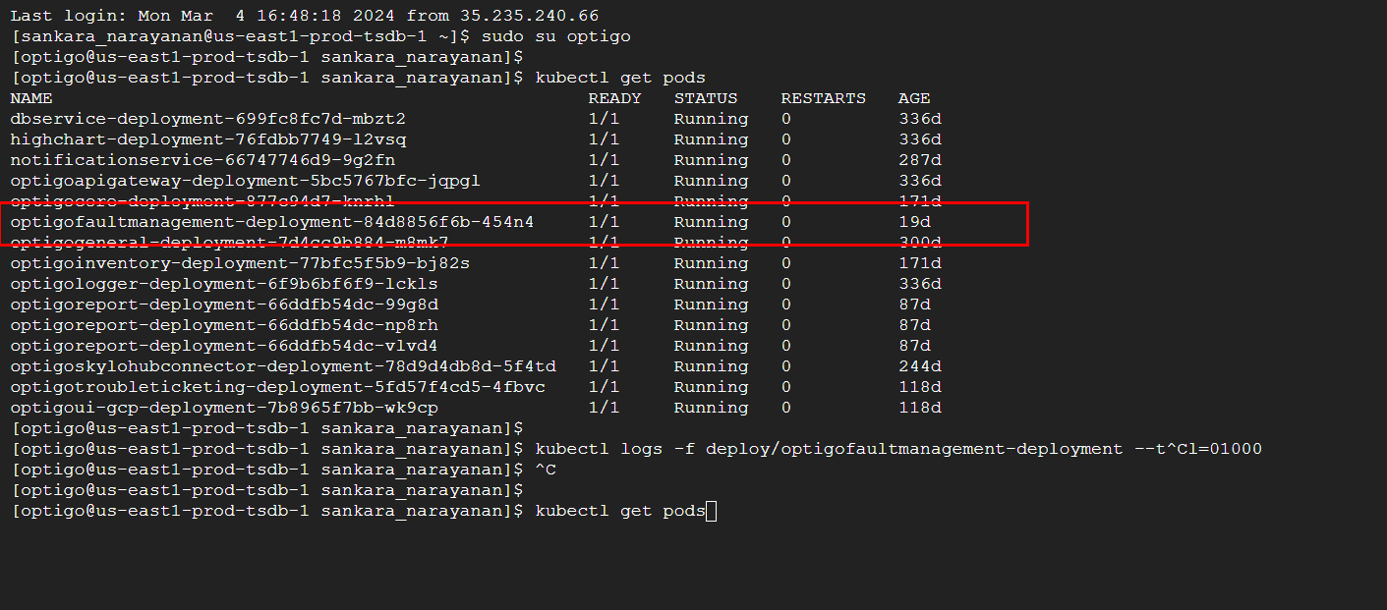

For analysing the logs of fault management we have to see the running logs of the pod.   
  
 enter the following command for analysing the micro services log off fault management

“ kubectl logs -f deploy/optigofaultmanagement-deployment --tail=01000 “

In logs we can able to see the select query from where the data being selected from the database and where it is being inserted in this case it is hive that is why we are seeing hive query being printed in the logs.

