GIS Explorer

Explorer is used to visualise the coverage of a network component it is used for defining the contors of a network element and provide visual insights of a component .



It is mostly used by the customer end NOC team . It is a static visualization of the coverage of a network component and it is a manual input of file

which is basically KML file queen insert in the KML management .

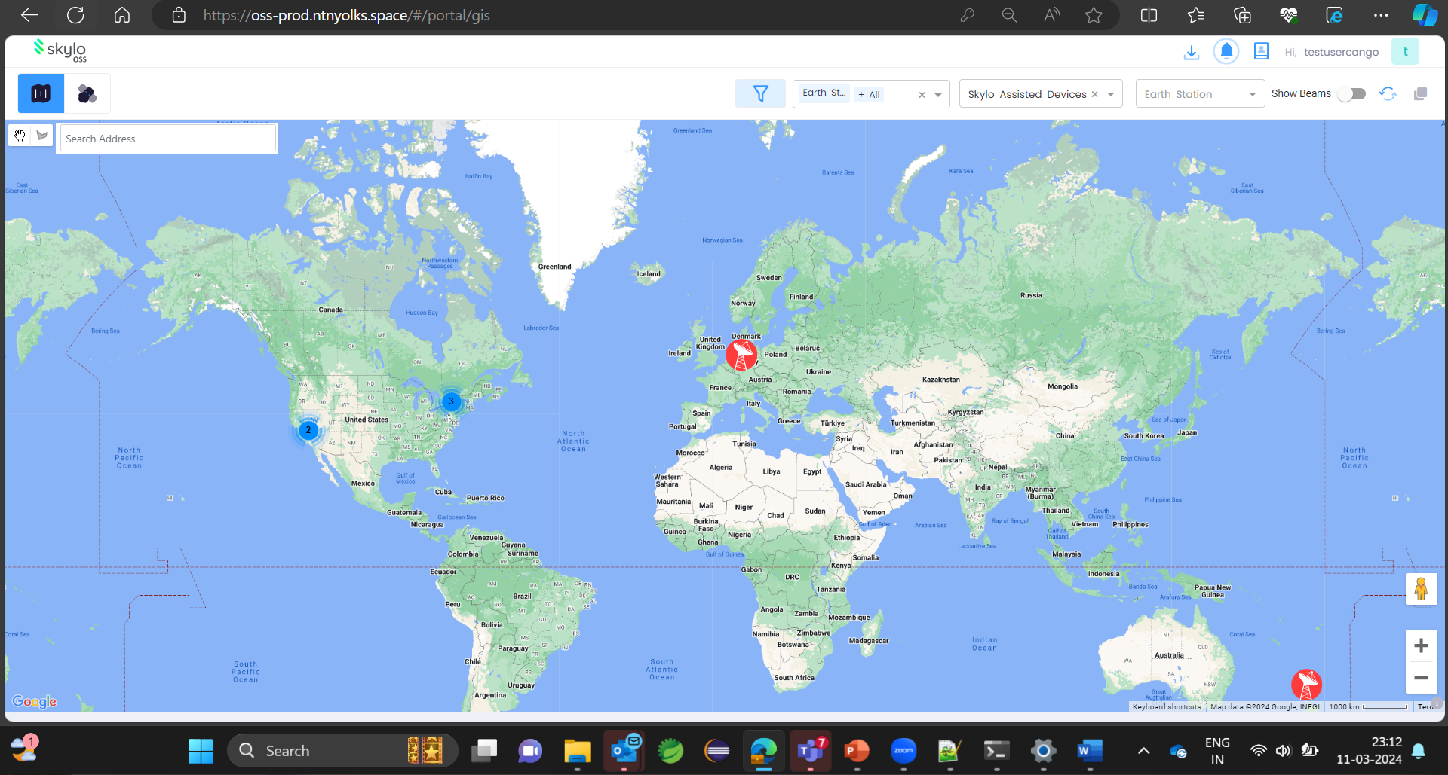

In this image Contors will be shown .

When we toggle show beams

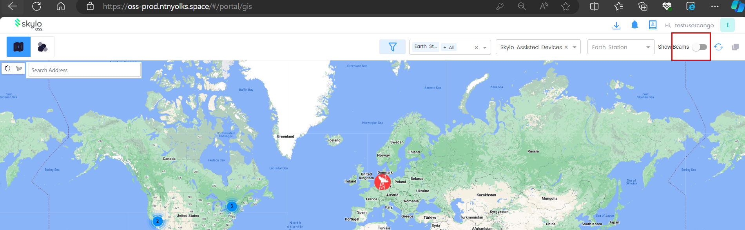

Beams and contors will be shown

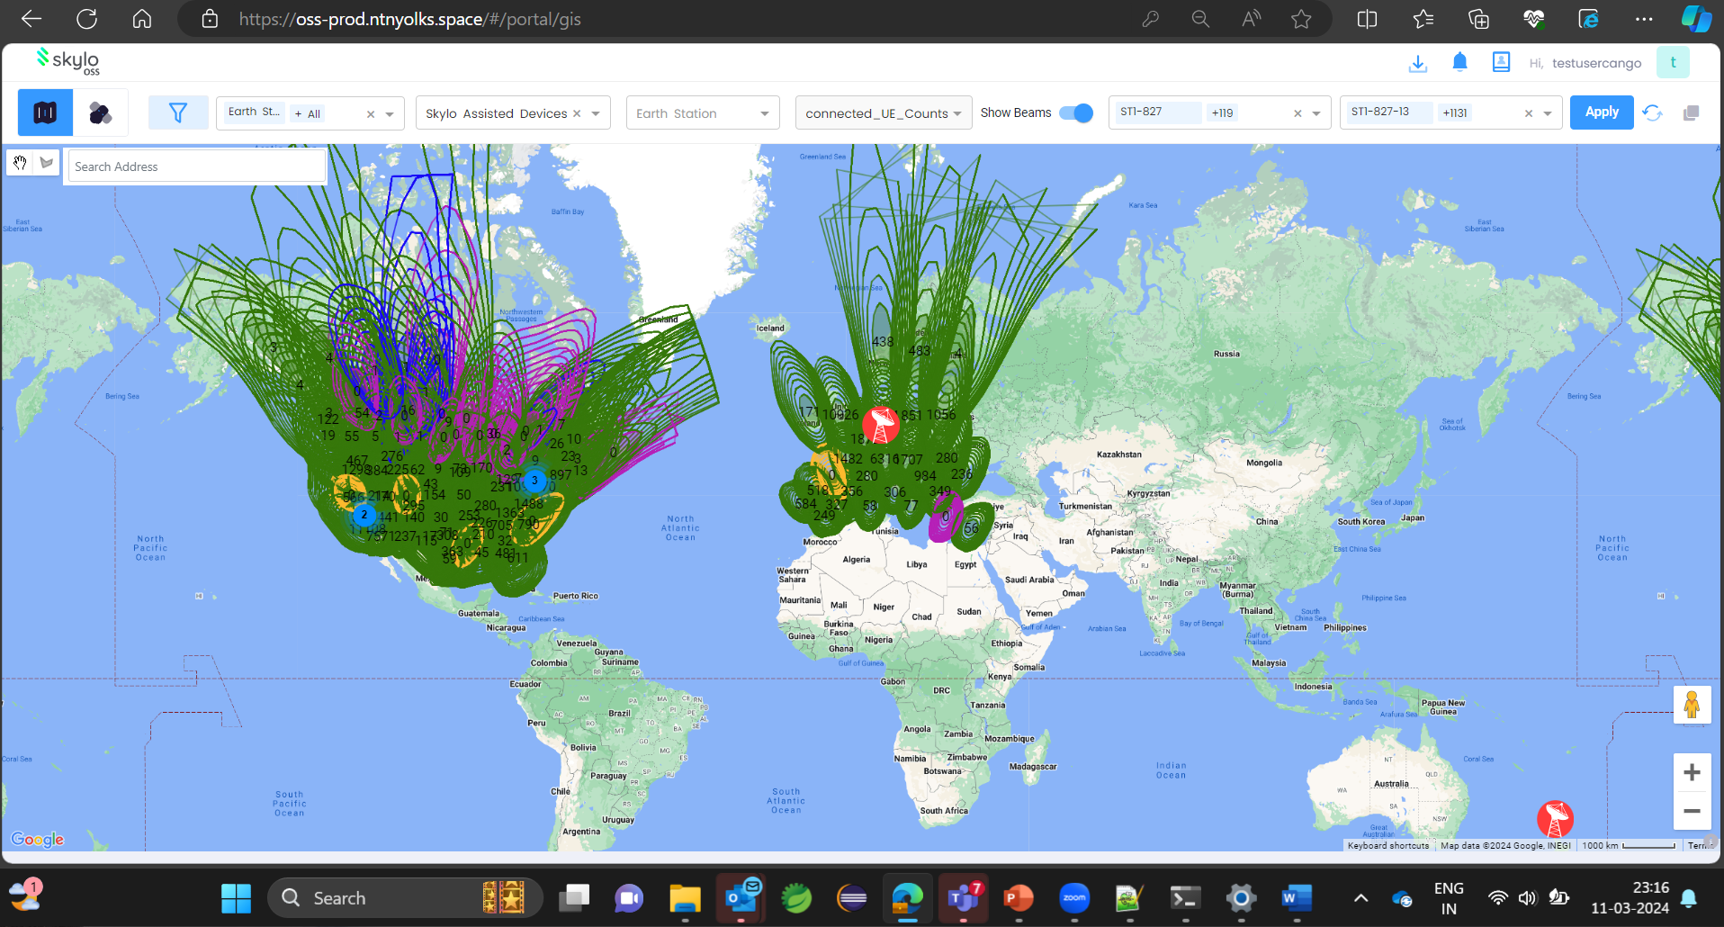

In inventory under satelites channels are added which will be reflected in GIS explorer , channels contains satellite id , skylo beam id , **Skylo Channel ID , Device name etc .**

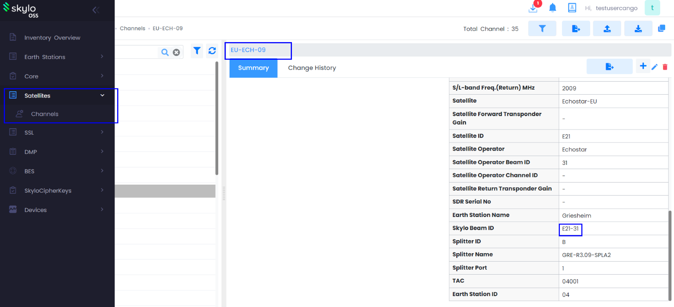

Beams in GIS Explorer will be provided by customer as a KML file then it will be added in Admin module

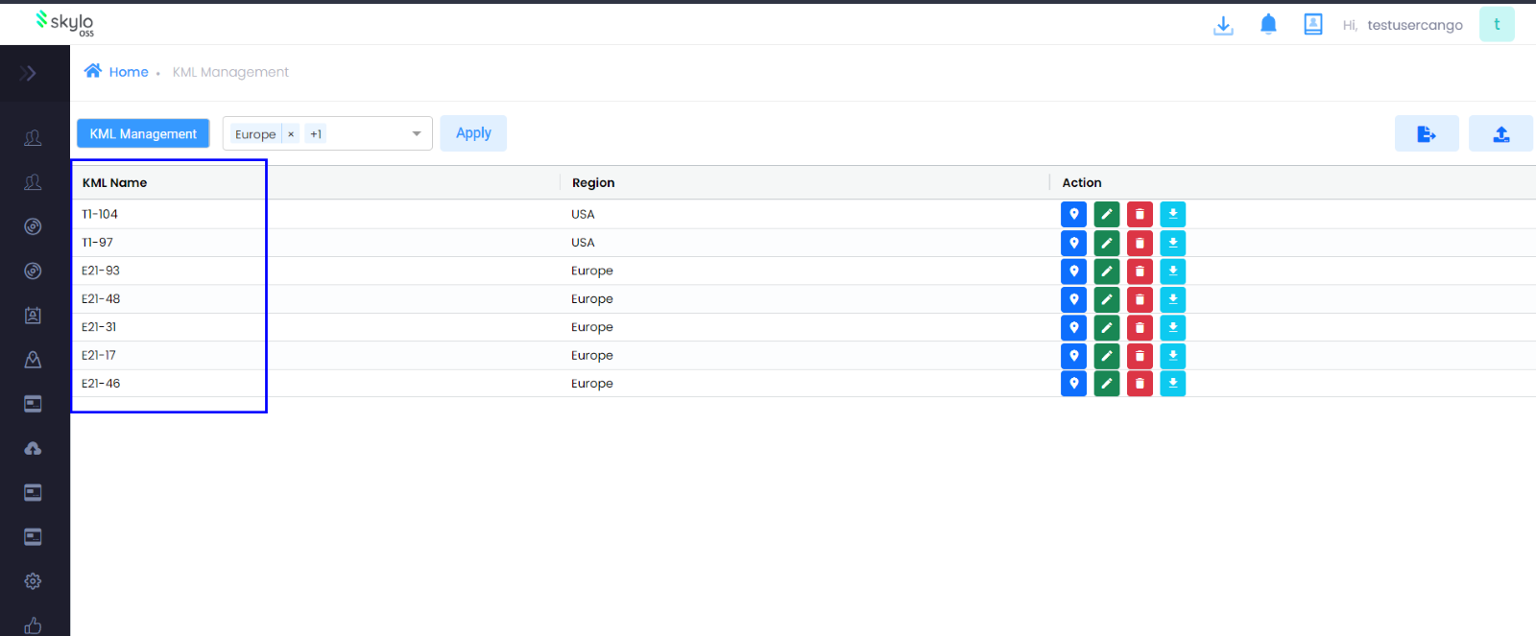

The uploaded KML file will be reflected as a beam in GIS Explorer

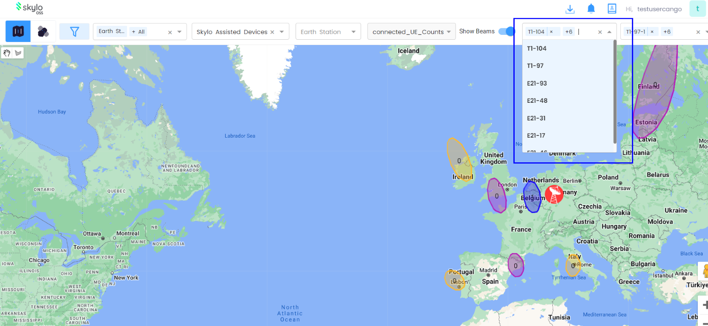

We can select the required KML and the cantor's for the kml will be displayed in the GIS explorer

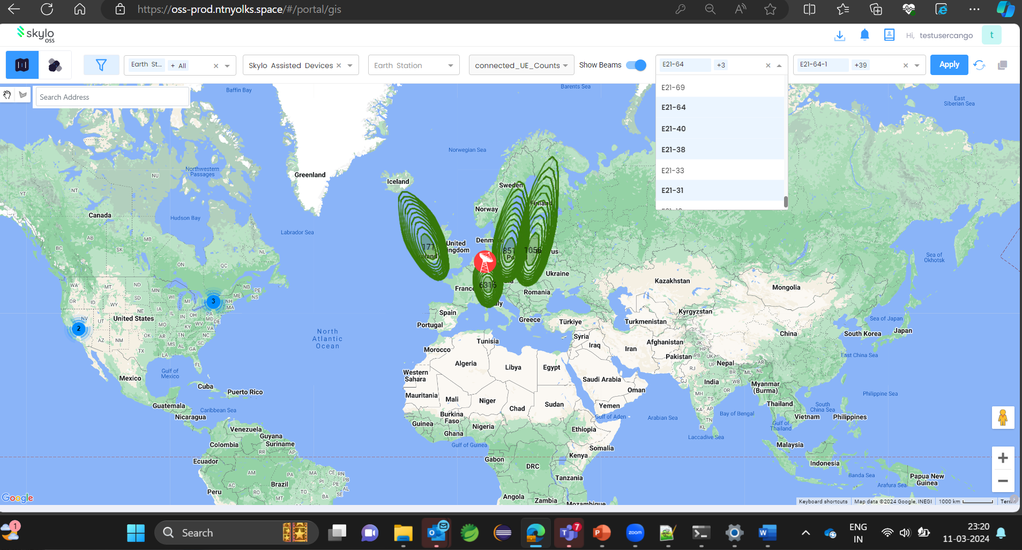

We we can either select or unselect the counters from the counters drop down shown below thank

