

How to recover software on an MTS-4000 V2

This procedure is very similar to the one presented in this [article](https://www.viavisolutions.com/en-uk/support/knowledge-base/faq/how-recover-software-mts-tbebd-2000-4000-6000-or-8000-will-not-boot) for the MTS-2000,

4000 V1, 6000 and 8000. The main difference being how to access the boot menu.

**What you will need:**

* A laptop, ideally with windows 10 or 11,
* A thumb drive, formatted in FAT-32, ideally empty,
* Physical access to the unit.

**How to Proceed:**

1. **Get the software:**

First, you will need to put the latest MTS-4000 V2 software version onto the thumb drive. You can find our latest software version [here](https://4kv2.updatemyunit.net/).

Once you have downloaded the executable file, you will need to extract its content onto the thumb drive. To do so, simply right click on the file and select “extract here” (option usually provided by 7-zip by default). Then select your thumb drive as a destination. If you are using Windows 11, you will probably need to press “show more options” to have this presented to you. Once the process is finished, you may carefully unplug your memory stick.

1. **Boot on the thumb drive:**

Now, make sure your unit is turned off, and set to charge (the process will not be possible if the unit is functioning on battery). Plug in the thumb drive and turn on the unit. As the unit starts up (or attempts to), you should see the Viavi logo in purple on a white canvas. Press the little square on the bottom left of the “A” as shown in the bellow picture:

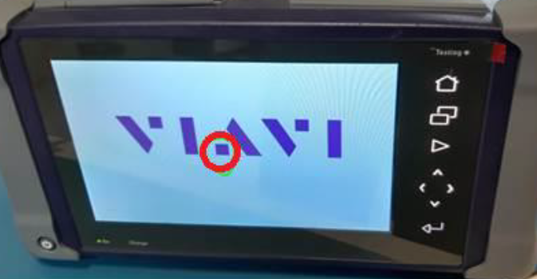

You should hear a loud “Bip”, and after a few seconds, the unit should prompt you to a boot menu.

The boot menu should look like this:

Press the upgrade option and let the unit upgrade itself.

If you do not see the upgrade option, the upgrade material on the USB stick is not being detected. Check the following:

* The thumb drive is formatted in the correct format,
* The upgrade material is on the drive and is the only material there,
* The unit is plugged into the AC.

If despite this, the problem persists, there might be something wrong with the USB port of the unit. Contact the [hotline](mailto:hotline.europe@viavisolutions.com) for assistance.

Once the recovery process is finished, you may turn on the unit as usual. If your unit does not turn on or if your problem persists, contact the [hotline](mailto:hotline.europe@viavisolutions.com) for assistance.